20 Ways to Celebrate International Women’s Day

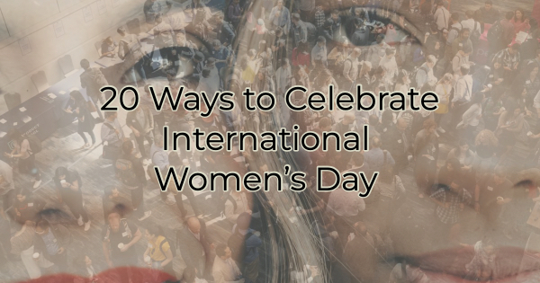

March 8, 2022, is International Women’s Day when the world celebrates the many contributions of women everywhere. If you’re not sure how to celebrate, we have some ideas for you and your business.

For the ideas in this article, think across multiple mediums to add content on your blog, in videos, reels, podcast episode, audio quotes, social media posts, etc. The same content can be repurposed in different formats to ensure everyone can find their favorite way to enjoy it.

20 Ways to Celebrate International Women’s Day

Here are a few ways you can show your support for women:

- If you’re a woman-owned business, tell your story and the challenges you overcame to open your doors.
- Share a story about a woman who inspires/inspired you.
- Tag women who inspire you in pictures on social media (but make sure you know them personally). Tagging someone you don’t know—while flattering—is like interrupting a conversation. It’s just not considered polite.
- Talk about your experience with bias or gender inequality either something you’ve experienced or something you’ve heard of.
- If you’re a woman working in a non-traditional field for your gender, help someone who’s thinking about doing what you do.
- Review your business policies to see if they are fair. Do you offer flexibility? Is there a job in your business that could fit the hours of moms whose children are in school?
- Have a tough conversation about why people have left your employ. Were any of them women or moms who felt uncomfortable in their surroundings or felt like it was difficult to work in your business/industry?
- Read a historical piece giving advice about women or to women. How has that advice changed? Share your findings with your audience.
- Be thankful for the opportunities that exist now and share words of gratitude.
- Talk about how you’re a progressive employer or how you intend to become one. Use specific examples.
- Host a flash meetup or plan an event for next year honoring women or strides made by them.
- Visit a nursing home or retirement home and speak with women about their memories and the challenges they faced. Use what you’ve learned there to develop a newfound appreciation of the struggles faced by women.
- Research the first women in your field or industry and talk about their experiences and history.
- Call a few of your female peers and invite them to breakfast or lunch that day.
- Create a resources for women page on your website (if it makes sense for your business).
- Challenge yourself to buy from female business owners for a day (week, month, season. etc).
- Volunteer at a women’s shelter, girl’s group, or women’s business association.
- Ask women what advice they wish someone had given to them about the workplace or industry they work in. Put their suggestions together and share it with your audience.
- Share a favorite recipe, way of doing something, or advice from a woman who was influential to you.
- Read a book or article about women across the globe. How do their experiences differ from yours or the women you know?

International Women’s Day is about celebrating women and their accomplishments whether those accomplishments involve starting what becomes a Fortune 500 company or raising a kinder generation. Women of all walks and educational levels contribute to our society. How will you honor them?

Christina R. Metcalf (formerly Green) is a marketer who enjoys using the power of story and refuses to believe meaningful copy can be written by bots. She helps chamber and small business professionals find the right words when they don’t have the time or interest to do so.
Christina hates exclamation points and loves road trips. Say hi on Twitter or reach out on Facebook.

