4 Psychological Techniques for Increased Sales During Small Business Season

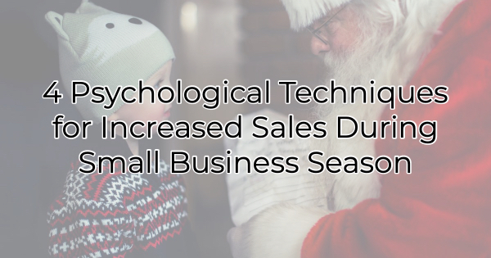

It's a noisy world out there and there's lots of competition. If you want to stand out, you must provide excellent value and persuasive copy. Without these two things the holiday season will not be the boon you are hoping for. Luckily, creating copy that drives your audience to action is very easy during the holiday season. While many people have a strict budget this year, they want to provide a nice holiday for their friends and family. That means they are looking to buy. Here's how you can help them decide to buy from you.

Effective Sales Psychology Techniques for the Holiday Season
Holiday purchases are often impulsive. A shopper sees something and without much thought decides it would be perfect for someone on their list. As the holiday draws closer, less time and holiday budget are left, and panic ensues. This is an opportunity for your business for two reasons. First, little time and little money forces quick action. Secondly, providing good value and the perfect gift will make many a frenzied shopper appreciate you. If you make it easy to buy from you, customers will take note.

When energy for mental activity is low (like when holidays are fast approaching), self-control is often weakened (buying anything to just get the shopping checked off the long list of holiday to-do’s). The following ideas can help you sway needy shoppers into buying from you.

Make Them Believe It
Remember high school and how impressionable we all were? Labels and nicknames could color reputations for four years of school (and well into the future). Maybe you were labeled brainy or cool or something less appealing. People saw you through that filter.

The same can be true of how you label your products or services. If you claim things like, “This is the perfect gift for your hard-to-buy-for friend” or “Every dog loves these bacon treats,” last-minute shoppers will believe you and act accordingly. You may have hated labels in school, but they go a long way to driving purchases in the weeks leading up to the holidays.

Use a Reason
Along those same lines, and pulling from the seminal influence study by Robert Cialdini that found people responded positively when presented with a reason, using a simple “because” can make people much more likely to honor your request. Keep this in mind when creating copy (or even videos). Give people a reason to buy your products or services. “This is perfect for the budding artist because…” or “Our service will delight your family because…”

Catch People Enjoying Your Offerings
Social proof is an effective motivator for purchases. When people see customers buying from you, enjoying your establishment/offerings, or talking about you, they’ll want to be a part of it. If you have a full store, take pictures or video of the crowd. Interview those who are shopping, especially your regulars. A few seconds of them sharing why they love coming to your business can drive many more to check you out as well.

Promote Discounts, Not Fees
No one likes to be penalized for their behavior, yet a lot of businesses are now charging shoppers credit card processing fees. This can leave a bad impression at check out for people . using the convenience of paying by card. Remember, just a year ago some businesses were refusing cash and insisting people pay through a touch-free interface.

But with the rising costs of credit card processing fees, what’s a business to do? In this situation you have two options. Either increase the price of your offerings to cover the increased fees (so no one sees them) or pass it along as a “nostalgic” discount for using cash. If you give the cash user discount a fun name patrons may be less likely to be disturbed by the upcharge for using plastic.

If you want to increase sales this Small Business Season, think about how you can use psychological incentives to drive more business. Value and experiences give small businesses an advantage this holiday season. If you use those things as a focus in your marketing, you’ll have a stellar season.

Christina Metcalf is a writer/ghostwriter who believes in the power of story. She works with small businesses, chambers of commerce, and business professionals who want to make an impression and grow a loyal customer/member base. She loves road trips, hates exclamation points, and believes the world would be a better place if we all had our own theme song that played when we entered the room. What would yours be?
_______________________________________
Twitter: @christinagsmith
Facebook: @tellyourstorygetemtalking
LinkedIn: @christinagsmith

