6 Local Business Growth Tips to Retain Your Authenticity While Scaling

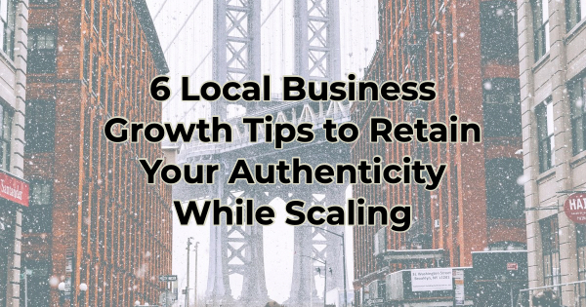

When Shakespeare wrote, “And though she be but little, she is fierce,” he could’ve been referring to small business. The term “small business” often seems like an oxymoron. What small businesses lack in number of employees, they make up for in dedication, drive, giving back to the community, and unique charm. Those things resonate with customers seeking authenticity, personalized service, and a sense of community.

But when it’s time to grow, and take your business to the next level, you want to make sure that the very thing about you that is so appealing isn’t lost. You want to maintain your distinct local essence, and strike that delicate balance between growth and preserving your identity in the hearts and minds of your audience.

Embrace the Strength of Community Engagement

At the heart of any local business's success lies its relationship with the community it serves. Strengthening this bond can be a catalyst for growth. Engage with the community through events, sponsorships, and collaborations with other local businesses or organizations. This involvement not only enhances visibility but also reinforces your commitment to your roots, no matter how many locations you open.

Hosting workshops, supporting local causes, or participating in community events can continue your position as a trusted and valued member of the neighborhood. Moreover, actively seeking feedback from patrons and implementing their suggestions to tailor products or services can help you meet local preferences. This will continue to foster loyalty and word-of-mouth marketing.

Leverage Digital Platforms But Keep the Personal Voice

In the beginning, your social presence probably felt very personalized because you were likely the voice behind the business. But as you grow, your abilities are needed elsewhere. Posting to social media is likely one of those things you will outsource or entrust to someone in-house. But make sure you don’t lose your voice. Work with someone who will adopt the same tone and post on the things your audience is most interested in. Retain that local flavor that characterizes your business.

Utilize social media platforms to share stories, behind-the-scenes glimpses, and testimonials, showcasing your business's personality and values. Maintaining responsive communication online, along with personalized service through other channels, creates a seamless blend of technology and tradition, enhancing the overall customer experience. Additionally, give your audience multiple ways to interact with you to obtain resolutions to their questions and concerns. You don’t want someone feeling like now that you’ve grown, you’re less responsive.

Cultivate Unique Offerings and Specializations

If your success is due to specializing in niche products, services, or markets, don’t give that up unless they’re no longer lucrative. Don’t think that because you want to grow, you need to appeal to a wider audience. After all, that specialization was a unique selling proposition (USP), and it helped you build what you are today—drawing customers seeking distinctiveness and quality over mass-produced alternatives.

If that product or service is no longer as successful as it once was, try figuring out why. If your audience is the same, how have their needs or desires evolved. You can serve the same audience, but you may need to do it in different ways.

Foster Partnerships and Collaborations

Collaborations with complementary local businesses can be mutually beneficial, amplifying visibility and attracting diverse customer bases. For instance, a café might partner with a nearby florist for themed events or collaborate with a local artist to display and sell artwork within its space.

Additionally, forming alliances with nearby businesses to create joint promotions or loyalty programs can encourage cross-pollination of customers, fostering a sense of community among various establishments. You see this in digital marketing all the time when senders plug their peers in their newsletters. They are simply sharing audiences.

Expand Thoughtfully and Sustainably

Expansion doesn't necessarily mean extensive physical growth. Consider alternative avenues such as online sales, pop-up shops, or partnerships with local markets or fairs to reach new customers without compromising the small business ambiance. Establishing and managing multiple locations isn’t for everyone.

If you are interested in physical expansion, prioritize locations that align with your business's standards, values, and appeal. Think of your audience and its needs. Retaining a coherent brand identity across multiple locations is crucial to preserve the local feel when expanding your business's footprint.

Take a look at Grimaldi’s. It opened in 1990, in a small neighborhood under the Brooklyn Bridge referred to as DUMBO. It started humbly as a local pizzeria; but quickly became part of the heart and soul of the growing community. As Grimaldi’s expanded into other markets, it could’ve shed its Brooklyn vibe, being just another pizza place. But it held onto its roots and sold New York-style pizza in a New York ambiance. No matter which location you visit—Las Vegas, Dallas, or Tampa—you will be in Brooklyn, NY back in the neighborhood.

Invest in Employee Development and Customer Service

The backbone of your business's success lies in your employees and the quality of customer service they provide. Invest in employee training because your employees are your business personified. They communicate your business's values and commitment to personalized service in every interaction. Happy and well-trained employees contribute significantly to a positive customer experience, fostering loyalty and word-of-mouth recommendations.

Maintaining a high standard of customer service, coupled with a personalized touch, distinguishes local businesses from larger, impersonal corporations, creating a lasting impression on customers.

Successful small businesses possess a distinctive charm that resonates with customers seeking genuine connections and unique experiences. While expansion is a natural progression, preserving your business's authenticity is imperative. Balancing growth and your special something is an art and takes practice and compromise. But with a strategic approach, you can continue to thrive, serving as a favorite in the community while embracing new opportunities for success.

Christina Metcalf is a writer/ghostwriter who believes in the power of story. She works with small businesses, chambers of commerce, and business professionals who want to make an impression and grow a loyal customer/member base. She loves road trips, hates exclamation points, and believes the world would be a better place if we all had our own theme song that played when we entered the room. What would yours be?
_______________________________________
Twitter: @christinagsmith
Facebook: @tellyourstorygetemtalking
LinkedIn: @christinagsmith

