7 Ways to Get Your Business Ready for the Holidays

The holidays are right around the corner and that can be a big spend time whether you’re in retail, hospitality, or services. It can also be a lucrative time for your employees as many people generously tip at the end of the year. But good tippers want a great experience and if your business isn’t ready for the holidays, it won’t just hurt your revenue. It could affect your employees’ earning potential as well.

Here are a few suggestions to help your business get ready and have the best holiday season yet.

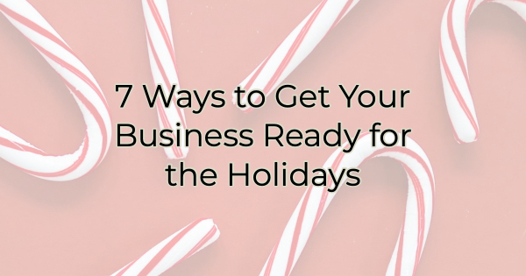

Start Marketing Holiday Specials NOW
Even if you’re in a business that’s not typically associated with holiday spend, tie your business in. For instance, if you change oil in vehicles, talk about service specials to get cars in shape for holiday travel. Insert yourself into buyers’ holiday-readiness checklist. The holidays are about a lot more than just purchasing gifts. There’s a lot of prep work to be done that can carry over into décor, furnishings, beauty industries and more.

Which brings us to…

Master the Offer
What will you offer to bring people in the door (or encourage them to buy from you)? Will you discount a popular product or service, host a free how-to clinic, run a webinar with a special discount at the end, offer a BOGO deal, provide a buy now/save later opportunity, offer a gift with purchase or bonus gift card, organize a contest or passport program with other businesses? There are so many ideas to excite potential customers. Choose one and start marketing it ahead of time.

Create a Spotlight
People have a lot on their minds these days. Holidays are particularly stressful. Anything you can do to make buying from you easier will stand out. Ideas like a gift-giving guide, a holiday services menu, or a buy online and pickup in the parking lot can all be great ideas to drive business. Decide what you can do to make your customers’ lives easier and market that.

Increase Your Marketing
Whether you’re paying for ads and marketing opportunities or going the free route, people are overwhelmed right now. The ability to bring in holiday customers with marketing can come down to the timing of your message, reaching them right when they’re deciding. So, you need to be everywhere. Increase your social media posting. Double down on your emails. Increase your content. But as you’re doing this, focus on what your customers need and it’s not more noise. They need you to help them in a very directed manner. Provide them with valuable information and easy access to your products or services.

Establish Vacation Policies
If you don’t already have an established policy, get one. Do you award vacation based on seniority or first-come, first-served? To avoid upsetting your employees, make sure everyone knows how you decide time off during the holidays.

Once you have a policy, be proactive and ask who needs what time. You may consider offering an incentive to work the times that are less popular like Christmas Eve.

Hire and Train Seasonal Employees
It’s nearly impossible to offer exceptional customer service and an unforgettable experience with burned out and overworked employees so you want to ensure you’re adequately covered for the holidays.

Consider your coverage needs. Do you have enough employees? If so, when advertising your open positions, make sure you focus on what’s in it for them (besides a paycheck). Is it a nice work environment (why?)? Do you offer a discount (how much)? Are there additional perks to employment? If you offer an employee discount, explain what they could save on Christmas gifts. Talk all this up in your advertising/job posting and your business will stand out. Be as descriptive as possible.

Give Employees Something to Get Excited About
Years ago, the company Christmas party was talked about and planned for throughout the year. But these days it’s become another obligation in a very busy time of year. Consider what your employees want most. Do they enjoy that fancy dinner and the open bar? Would they enjoy it more after the rush of the holiday season? Would they rather have a cash bonus or a gift?

Maybe your employees are more altruistic. Would they enjoy sharing their blessings by working on a company project and helping a charity? Maybe even one you could pull in customer support for. You don’t have to host a holiday party. Tailor your year-end celebration to what your people will get the most excited about.

Christina Metcalf is a writer/ghostwriter who believes in the power of story. She works with small businesses, chambers of commerce, and business professionals who want to make an impression and grow a loyal customer/member base. She loves road trips, hates exclamation points, and believes the world would be a better place if we all had our own theme song that played when we entered the room. What would yours be?
_______________________________________
Twitter: @christinagsmith
Facebook: @tellyourstorygetemtalking
LinkedIn: @christinagsmith

