Business Recovery Post-Pandemic: What Changed and Should You Change It Back?

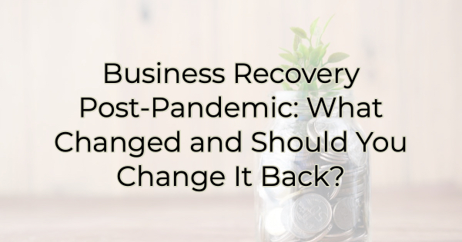

COVID and labor shortages have caused a lot of businesses to reevaluate offerings and pivot how they did business. But if you’re like many business owners, while adapting to customer needs was a critical component to staying in business, you may now realize that you are off track.

It’s important to provide value to customers but veering too far away from your true business can cause you to take on too much too soon. For a pre-COVID example, when restaurant Planet Hollywood experienced great success initially, they spread themselves too thin ultimately forcing a lot of location closures. If you made a change to your business during the pandemic to meet customer needs, it might be time to reevaluate what was done and see if it is still in keeping with your business mission and vision.

Ways Businesses Change and What They Mean Today
There are many reasons to change your business. Some changes may provide long-term solutions others are short term panaceas. But if you did any of the following over the past three years, it may be time to reevaluate whether these changes are still serving you and your customers.

New Offerings
During the pandemic and subsequent inflationary times, many of us implemented things that are outside our usual offerings because it was a way to stay in our customers’ lives and entice them to continue opening their wallets for us.

It’s probably time to reevaluate those new offerings. Were they a good addition to what your business did before? Are they making you money? Are they providing a needed solution for your customers? Have they caused your employees or customers to become more loyal? Do you still enjoy the work you are doing?

All these things are good indicators of whether those changes were just a needed bandage to get you through tough times or something you should keep going and grow.

Limits
Did you limit your business in any way to survive the pandemic? For instance, many restaurants created shorter menus or rearranged their seating areas. Do the limits you’ve placed on your business still serve you? Maybe you’ve found that by limiting choices, you’ve perfected the upsell. Maybe your roomier interior design has encouraged people to spend more time browsing and thus increased sales or maybe the opposite has happened. Maybe you’ve decided you need more tables again and it’s time to bring them back. Revisit the limits you implemented for survival and see how they suit you now. Are they contributing to growth or limiting it?

Services and Products
Many product selling businesses looked for ways to sell services and many service based companies started selling a line of products during the pandemic. How are those new areas serving you? Did they open a new market or are they languishing? Are you marketing those things with growth in mind or were they just to get you through the tough times?

Working from Home
Many businesses allowed employees to work from home and now they’re finding difficulties in convincing people to return to the office or hiring new people who want to work outside of the home. It might be time to reevaluate your office space needs. You may find it’s cheaper to operate out of your home and use your local chamber or business incubator for meetings (if they have space).

Nearly three years since the pandemic began and with an inflationary period on our doorsteps, it’s likely a good time to reexamine the changes you implemented for your business. Are those changes still serving you or is it time to sunset them?

Christina Metcalf is a writer/ghostwriter who believes in the power of story. She works with small businesses, chambers of commerce, and business professionals who want to make an impression and grow a loyal customer/member base. She loves road trips, hates exclamation points, and believes the world would be a better place if we all had our own theme song that played when we entered the room. What would yours be?
_______________________________________
Twitter: @christinagsmith
Facebook: @tellyourstorygetemtalking
LinkedIn: @christinagsmith

