Customer Loyalty: The One Thing Every Business Owner Wants This Year

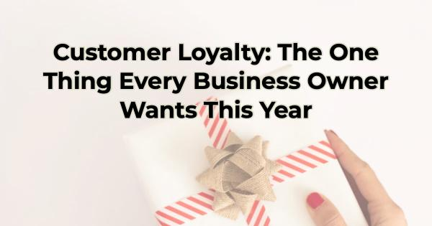

If every small business owner had the opportunity to write a letter to Santa (or whoever grants Christmas wishes to business owners), they would likely all ask for the same thing—more loyal customers. Sure, the ask may sound different in each form of correspondence. It may be a request for more customers, higher revenue, more reviews, and the like. But all those things boil down to loyalty. Loyal customers spend more, tell others about their experience, refer people to your business, post to social media about you, and return over and over. They may even write a review or two. Building a loyal customer base is better for your business in the long run than simply getting more customers.

Building an army of loyal fans is no different than finding someone you care about the perfect gift. If you’ve ever done that, you can increase customer loyalty in your business. Here’s how:

Tips for Creating Customer Loyalty—the Best Gift You Can Give Your Business
If you want loyal customers, you must approach it in the same way you would any relationship. You must build it carefully, deliberately. This is not a transaction. You don’t flip a switch and see loyal customers outside your door waving their money at you for a Wonka Bar like the frantic scene in Charlie and the Chocolate Factory. Instead, you need to go about building loyalty with the same painstaking interest you would in buying your significant other that first thoughtful gift from you.

Understand the Recipient: Know Your Customers
The foundation of any meaningful relationship, be it personal or business-oriented, lies in knowing who they are and what they want. It’s common for people in a good relationship to say of the other, “They get me.” You need to help your target market feel the same about you.

To cultivate loyalty in business, you need a deep understanding of the customer. If you have the budget, conduct market research. Regardless of budget, everyone can pay attention to customer feedback and gain insights into their preferences, behaviors, and pain points. Just as selecting a gift requires knowing the recipient's tastes, building customer loyalty involves recognizing what your customer values most.

Tailor the Gift: Personalize the Customer Experience
When selecting the perfect gift, personalization is key. To achieve something meaningful, you don’t go with a gift card. You could give that to anyone. The same principle applies to customer loyalty. Tailor your products or services to meet the unique needs of your ideal customer. Utilize analytics to create personalized experiences for different marketing personas or types of customers you have. For instance, if you owned a candy store and most of your customers fell into two demographics—people under 25 and people over 40, you should sell to them differently because they have different desires. Your under-25 buyers might prefer sour candies and lots of them, while your over-40 customers may tend to buy fewer items but expect higher quality, looking for a luxury truffle, or perhaps a candy from their childhood, for example. You should appeal to your different types of customers by tailoring offers, exclusive discounts, or personalized communication. You want your customers to feel like your offer was written just for them.

Anticipate Desires: Stay One Step Ahead
Much like anticipating someone's desires when picking a gift, you want to proactively address your customers’ needs. Try to predict trends (or analyze how a popular trend may impact your products or services), introduce innovative options, and continuously improve your offerings. Again, this will make your customers feel like you know what they want and need. When someone feels like you’re looking out for them, you will be one of the first they think of when searching for the product or service you carry.

Understand Fears: Address Customer Challenges
Just as a thoughtful gift-giver considers what the recipient may face in life and gives a gift that can help with that, successful businesses must look out for customer concerns—both the ones the customers are aware of and the ones that could be a potential source of frustration in the future. Your marketing should address those challenges and show how you can help.

To create a more loyal customer base, you also want to remove any friction from their buying experience. For instance, if you’re offering a sale that seems “too good to be true,” make sure you use language that is clear and speaks to your ideal customer to remove any hesitation.

Build an Emotional Connection: Go Beyond Transactions
The most cherished gifts are often those that evoke emotion or give of oneself. Similarly, businesses can build lasting customer loyalty by going beyond transactions. Foster an emotional connection by telling your story, engage with customers on social media in a human way, share of yourself and your time, and demonstrate care for them. A brand that resonates on an emotional level will help customers view your business as more than just a provider of goods or services.

Building the relationship that creates customer loyalty is a gift for your customers and your business. It requires an understanding of your audience, a commitment to personalization, and an ongoing effort to exceed expectations. These are not small undertakings. But just as the ideal gift is appreciated by your loved one, your customers will value the relationship you are building and reward you with more referrals and revenue.

Christina Metcalf is a writer/ghostwriter who believes in the power of story. She works with small businesses, chambers of commerce, and business professionals who want to make an impression and grow a loyal customer/member base. She loves road trips, hates exclamation points, and loves when a business offers a surprise thank you.
_______________________________________
Facebook: @tellyourstorygetemtalking
LinkedIn: @christinagsmith
Twitter: @christinagsmith

