During Small Business Season Don't Forget This

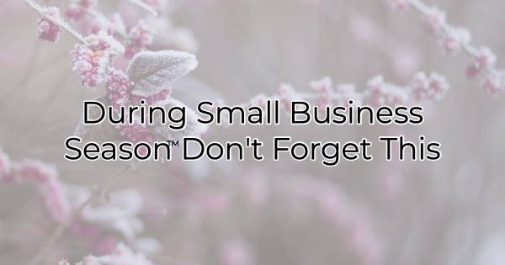

It's easy to get swept up in the stress of managing a small business during the holidays. But if you sell gift cards or are a participating business in a gift card program, there's one thing you want to make sure you don't miss.

While we use the term Small Business Season to refer mainly to the time between November 1st and December th, if you sell gift cards some of your busiest times this holiday will occur after people have unwrapped their gifts and before they return to work and school. Gift card recipients and people with returns often go shopping that week after Christmas. This year, Hanukkah coincides with Christmas week as well so you may have an even busier last week of the year.

That's why it's essential to prepare your small business for the week between Christmas and New Year's. But how do you do that?

- Create a targeted marketing plan. Decide what you'll offer and how you will communicate your specials. Treat this marketing plan differently than the marketing plan you created leading up to the holiday. This one has a different focus. Switch your messaging from “find the perfect gift” to “get yourself a little extra something” or “wind down after a busy holiday.” This shift in marketing can be especially effective for those in the wellness and service industries.
- Post your hours. If your hours are going to change after Christmas, make sure everyone knows about it. You also want to communicate to them if you're keeping extended business hours through New Year’s Day. Update your Google listing, as well as your website, social media, signs on your door and in your store.
- Provide bonuses. Due to the newly received gift cards and ill-fitting gifts, many shoppers return to stores immediately after Christmas. Consider what bonuses you will offer to ensure that they spend their holiday money with you quickly. It's easier to sell to people who already have reason to buy than it is to recruit someone who has never purchased from you. One of the reasons gift cards are so popular with merchants is that most people spend more at the business than they have on the gift card (the average is $59 more than the value of the card). When people feel like they're getting good value for their gift card and their money, they'll spend even more.
- Reward employees. It's likely if you've had a busy small business season that your employees are worn out. If you haven't already done so, this is an excellent time to show them your appreciation through rewards or sales bonuses.
- Ensure your business is ready for the crowd. Just because Christmas is over doesn't mean everyone will stay home. You still can attract a crowd. Again, not only do people have gift cards they want to use and items they may want to exchange, people have guests in town, college kids at home, New Year's Eve parties to shop for, Hostess gifts to give, as well as delayed Christmas and holiday parties. Extending your holiday hours for the week after Christmas can be a real positive for your revenue flow.

The small business season doesn't end with the passing of Christmas or Hanukkah. There's still at least another week left when shoppers will want to have access to your products and services. Make sure you're ready for them.

Christina Metcalf is a writer/ghostwriter who believes in the power of story. She works with small businesses, chambers of commerce, and business professionals who want to make an impression and grow a loyal customer/member base. She loves road trips, hates exclamation points, and believes the world would be a better place if we all had our own theme song that played when we entered the room. What would yours be?
_______________________________________
Twitter: @christinagsmith
Facebook: @tellyourstorygetemtalking
LinkedIn: @christinagsmith

