How Easy Is It to Do Business with You?

It’s not uncommon to hear old timers (of any age) complain that young people don’t have it as hard as they did. It’s a common lament that younger generations are not as battle worn as the Silent Generation.

Whether that is true or not remains to be seen.

But the one thing that is true is that people will not do business with you if you make it hard to do business. There’s just too much competition and not enough interest.

To attract sales and become interested in your business, you want people to know, like, and trust you. Once they are interested, your work isn’t complete. You want to make it easy on them to do business.

If you’re doing the following things in business, you may be missing sales because you are making it too hard.

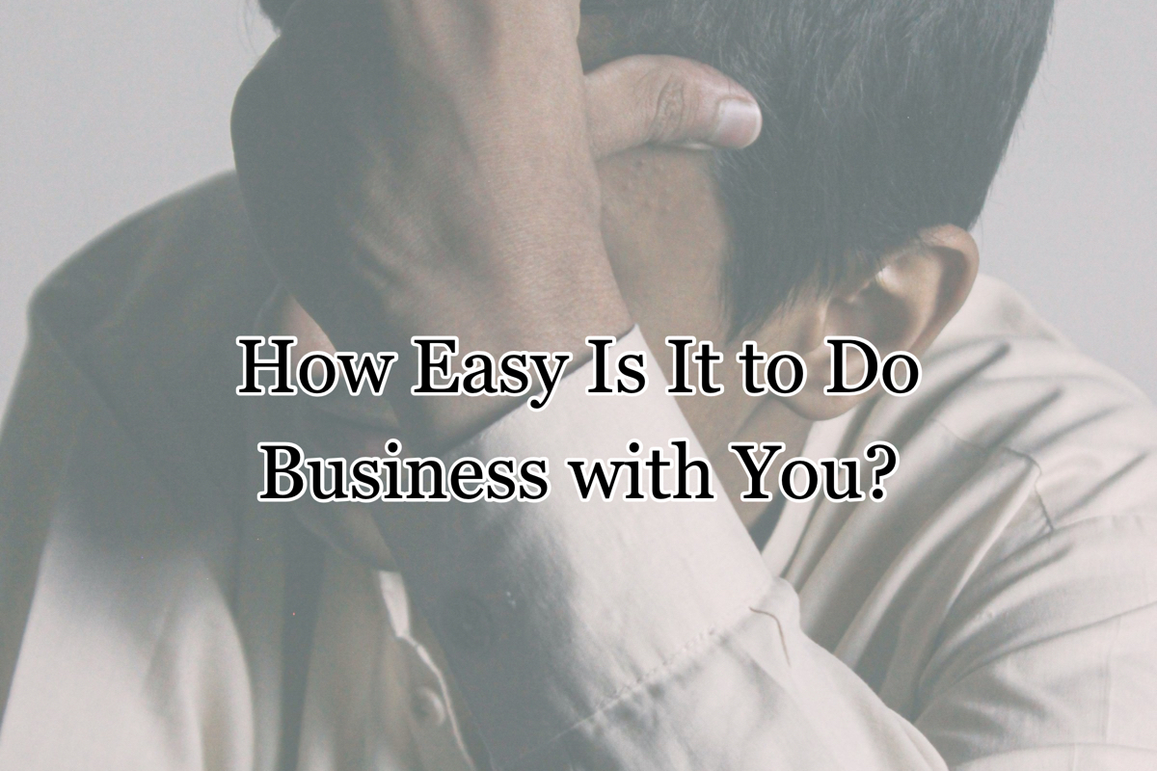

You May Be Making It Hard to Do Business with You If…

- You don’t have an online presence. It’s not quaint. It’s difficult. When someone wants to learn more about you, they go online. They may search for you because they’re curious about your hours or your contact information or they may want to order from you. Some people may have heard of you but don’t know what you do. There are many reasons someone would look for you online and if you’re not there in some capacity, you are missing out.
- There’s no social proof about you. Have you seen great deals advertised on Facebook? Do you click on them? What if you don’t know the business and the claim appears too good to be true? Are you hesitant to order? Probably. However, if there were reviews on a reputable site for this company or you were referred to them by someone you knew, you would be more likely to buy from them. If you want to increase sales, you need to empower people to talk about you. You need to ask for referrals and reviews.
- Your hours are limited. If you sell or enable customers to make appointments online, your hours don’t matter as much. But assuming you sell only in store, or someone needs to reach you to make an appointment, limited/unpredictable hours make it difficult to do business with you. People don’t want to wonder if you’ll be open. They want to know for sure before they go out of their way.
- Your business is unknown. If a customer isn’t sure how they would buy from you, they won’t. For instance, let’s say you are the first business in your town to do massage and no one there has ever heard of it. They might not know how they work. They may be worried that they will have to get completely undressed, or may worry that the robe you provide may not cover them, or a host of other questions that crop up with trying something new. In order to help people buy from you, you need to educate them and make them feel at ease. You can do this through content on your website, ads, etc. This advice doesn’t just apply to new businesses. For instance, people who are considering joining a gym will want to know if you are geared toward athletes, elderly, or those struggling with weight. They want to find their “people” at your business. Targeted content helps you convince them that they’re in the right place.
- You can’t stay staffed. A recent survey found 61% of businesses are struggling with this right now; but if you don’t have enough employees to guarantee a good customer experience, people won’t be back. You want to ensure your customers are receiving good service, but overworked employees aren’t always capable of that. Hire as quickly as you can and make the employees you have feel valued.

If you want more sales, make it as easy as possible to do business with you. If you do, you and your customers will be more satisfied.

Christina R. Metcalf (formerly Green) is a marketer who enjoys using the power of story and refuses to believe meaningful copy can be written by bots. She helps chamber and small business professionals find the right words when they don’t have the time or interest to do so.
Christina hates exclamation points and loves road trips. Say hi on Twitter or reach out on Facebook.

