How to Craft Irresistible Offers for Your Biggest Holiday Sales Yet

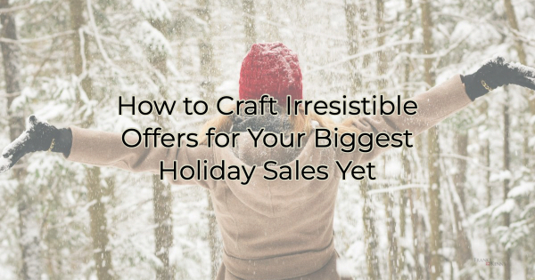

Small businesses everywhere are enjoying the trend of shopping local. Many organizations, including the Chamber, understand the importance of helping the community realize the value of small businesses. Even with this help, your local business still has two major challenges—marketing (making sure people think about you when they’re ready to buy) and convincing them that shopping local is not an expensive undertaking, especially when 69% of people are saying they’re going to reduce non friends and family buying. While pundits believe spending will increase over last year, albeit not be a large amount, the reality of that prediction is yet to be determined.

With the specter of reduced spending hanging over us to dampen this holiday season, you may be wondering what you can do to ensure customer spending is directed your way. Creating a compelling holiday offer can set your business apart and drive more sales.

How to Craft an Effective Holiday Offer

Here are some essential tips and ideas to help you craft a successful holiday promotion:

1. Know Your Audience
Understand your target audience's preferences and buying behaviors during the holiday season. Tailor your offer to meet their needs and expectations. Consider demographics, interests, and past purchase data to create a more personalized and appealing promotion. If you know they’re in a hurry, for instance, think of offers that will help ease those time tensions.

2. Set Clear Objectives

Clearly define your goals for the holiday offer. Whether it's increasing sales, attracting new customers, or retaining existing ones, having a clear objective will guide your offer creation. Sure, for the holiday increased sales is probably your main goal but attracting new customers can help you year-round so keep goals in mind when crafting an offer.

3. Make a Big Impression
You want people to think about you when buying so the more creative your marketing, the better. Keep in mind that everyone has an offer this time of year. You need something that will make people remember you. Ask yourself how you can make your offer more fun or memorable.

Types of Offers and How to Market Them
Now that you know what to consider when creating an offer, let’s talk about the different types you might market. While discounts are effective, it’s understandable if you don’t want to drastically reduce prices to erode your profit margin. Often, it’s not that large to begin with. Discounts aren’t the only options out there as you’ll see below:

Limited-Time Offers
Create a sense of urgency by introducing limited-time offers. Whether it's a discount, bundle, or exclusive deal, time-limited promotions encourage customers to make a purchase sooner rather than later. Clearly communicate the timeframe of your offer to instill a sense of urgency that’s why Black Friday deals drive purchases. People understand they need to act or lose out.

Bundle Deals
Package related products or services together at a discounted rate. This not only adds value for customers but also encourages them to explore more of what your business has to offer. Highlight the savings they'll receive by choosing the bundle. Internet marketers do this well. Notice how they show what everything is worth individually compared to what you’ll pay when buying them together. It’s a very effective method to show greater value.

Exclusive Discounts for Loyal Customers
Reward your loyal customers by offering exclusive holiday discounts, bonuses (like gift wrapping), or early access to your promotions. This not only fosters customer loyalty but also makes them feel appreciated, increasing the likelihood of repeat business.

Gift with Purchase
Entice customers with a "gift with purchase" promotion. Whether it's a free product, an accessory, or a special edition item, this strategy adds perceived value to their purchase and can incentivize larger transactions.

Leverage Social Media
Promote your holiday offer across your social media channels. Use engaging visuals, create shareable content, and encourage user-generated content with a branded hashtag. Social media is a powerful tool to create buzz around your promotion and reach a broader audience. Take forget the video platforms.

Mobile-Friendly Promotions
Optimize your holiday offers for mobile users. Many consumers browse and shop on their smartphones first before you see them in store, so ensure that your website and promotional materials are mobile-friendly to provide a seamless shopping experience.

Collaborate with Other Businesses
Consider collaborating with complementary businesses to create joint promotions. This can expand your reach and introduce your products or services to a new audience. Choose partners whose values align with yours for a more successful collaboration.

Personalized Email Campaigns
Leverage your email marketing strategy by sending personalized holiday offers to your subscriber list. Use segmentation to tailor messages based on customer preferences and behavior, making your offers more relevant and enticing.

Monitor and Adjust
Track the performance of your holiday offer in real-time. Analyze sales data, customer feedback, and website traffic to understand what is working and what can be improved. Be prepared to adjust processes to maximize the effectiveness of your promotion.

Take advantage of this festive season to not only drive revenue but also to strengthen relationships with existing customers and attract new ones to your business year round.

Christina Metcalf is a writer/ghostwriter who believes in the power of story. She works with small businesses, chambers of commerce, and business professionals who want to make an impression and grow a loyal customer/member base. She loves road trips, hates exclamation points, and believes the world would be a better place if we all had our own theme song that played when we entered the room. What would yours be?
_______________________________________
Twitter: @christinagsmith
Facebook: @tellyourstorygetemtalking
LinkedIn: @christinagsmith

