How to Make Your Product or Service Indispensable

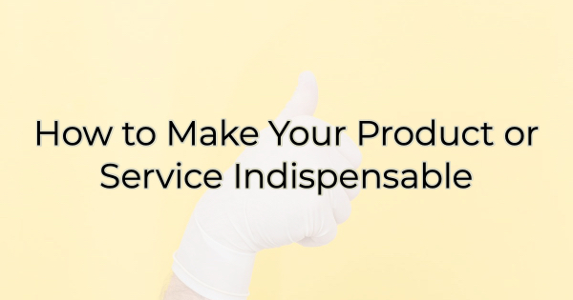

Unless you are extremely fortunate, there’s a lot of competition out there. Your product or service must compete against a host of other businesses not just in your town but, potentially, across the globe. You’re also in competition with inaction or doing nothing at all.

If you haven’t analyzed the competition lately, you may be surprised by the competitive landscape. This morning, I discovered the design software Canva has launched an auto-writing feature so now I (along with thousands of marketing writers) are now in competition with AI, of all things. And while I can spend hours writing about how AI-generated content will never be able to trump the acerbic wit of my fellow humans, the truth is that some people will choose to go with the machine rather than hiring it out. The same may be true for your business.

So, what can you do?

You must find a way to become indispensable. Here’s how:

How to Become Indispensable
Since each business and industry are different, I can’t give you a strategic plan of specific steps tailored to you, but we can go over ideas that can be tailored to your business.

- Know your market. You will never be indispensable to the entire world. Even someone who sells caskets must compete with the urn dealers. Don’t waste your time with those who will never be the right fit for you. Figure out who you help and concentrate on becoming indispensable to them. This can take discipline because we want to believe everyone could benefit from our business. But some customers are a better fit than others. Find them.
- Identify your competition. It’s easy to identify all the businesses that sell what you do. But take that a step further. Competition is changing on a (seemingly) daily basis. For instance, fitness apps are now going to be in competition with Netflix that plans to launch a series of exercise videos (in conjunction with Nike Training Club) on December 30th. Competition is becoming less direct than a brick and mortar down the street. Next, ask yourself if a buyer doesn’t take the route of buying exactly what you sell, what are their options. For instance, if you cut and color hair, your competition is other salons, home dye boxes/processes, and inaction. People who are considering doing their hair always have the option of not doing anything. For that reason, a baseball cap may be your competition. Once you figure out who or what you’re competing against, you can start to craft some fun copy/content around that. For instance building on the salon example, you could post, “Time to give that hat (or ponytail holder) a rest. Come in and see us. Appointments available for New Year’s Eve.” This step is important because content created out of this type of research/knowledge helps people identify with your business and think you are speaking to their specific needs. Speaking of…
- Realize why they need you/what they want/what’s in it for them. Why do people buy what you’re offering? Do they want to look better, feel better, move quicker? Then take that a step deeper. Think about something else they could achieve working with (or buying from you). Consider things that make life easier and help them fulfill dreams.
- Map out what’s holding them back. There’s a reason they’re not buying from you even though what you offer is what they need. Is there a barrier? For instance, if you run a gym, are they afraid there won’t be people like them there? Doubts lead to inaction. Do your best to address the doubts so you can speak more clearly to their needs.
- Talk about what happens if they don’t choose you or don’t act. What won’t they achieve if they don’t buy from you? What will they continue to struggle with?
- Consider extra content or services that can round out your offerings and make you indispensable. What can you add to your offerings to either create an experience or address additional needs they have. For instance, a business might add oil changes to its car wash, while a car wash could add a few gas pumps. Creating a one stop shop can help you bring in more revenue and save your customers time and money, making your business an obvious choice over the competition.

Becoming indispensable requires one thing above all else—a deep knowledge of your ideal customer. Once you know who that person is, you can offer them what they want, need, and can’t live without. Then all you have to do is convey that in your content and branding.

Christina Metcalf is a writer/ghostwriter who believes in the power of story. She works with small businesses, chambers of commerce, and business professionals who want to make an impression and grow a loyal customer/member base. She loves road trips, hates exclamation points, and believes the world would be a better place if we all had our own theme song that played when we entered the room. What would yours be?
_______________________________________
Twitter: @christinagsmith
Facebook: @tellyourstorygetemtalking
LinkedIn: @christinagsmith

