Money-Making Email Subject Lines for Small Business Season

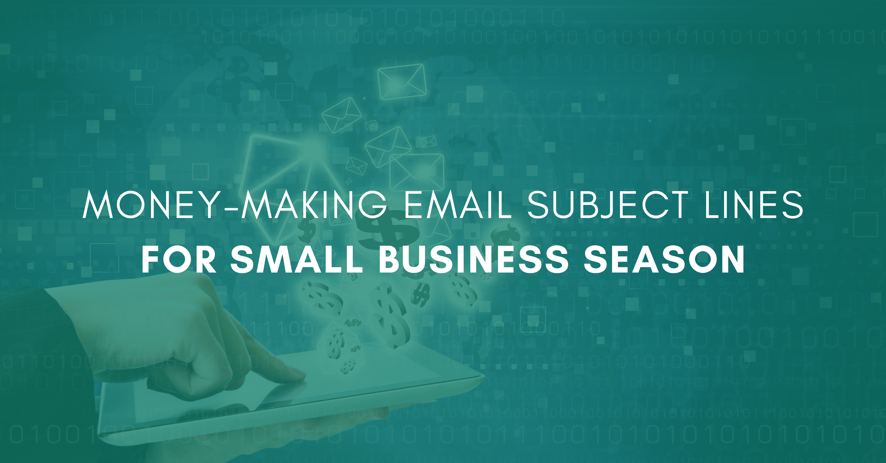

There's one more week left before Christmas, and it’s one of the busiest shopping weeks all year. Sure Black Friday and the Saturday before Christmas are the busiest days (spots 1 and 2 according to Sensormatic) but many of the other top 10 busiest shopping days in the U.S., are still on the horizon such as:

- #3 - Thursday, December 23 – Thursday before Christmas
- #5 - Sunday, December 26 – Day after Christmas, aka “Boxing Day”
- #6 - Wednesday, December 22 – Wednesday before Christmas
- #9 - Tuesday, December 21 – Tuesday before Christmas

If your small business is ramping up for those last-minute shoppers, don't forget email. Email marketing is an effective way to reach your ideal audience and help them come up with ideas for last-minute and/or hostess gifts. This can be a frantic time of year so any assistance you can give those struggling for the perfect gift will likely result in more sales.

Email recipients can’t respond to your call to action if they don’t open the email. The easiest ways to get them to do that is by creating subject lines that inspire action.

Here are a few tips on how to write effective subject lines to win over last-minute shoppers. The examples below are all basic ideas. Add your own flair to fit the tone of your business.

Free
If you’re giving something away for free with a certain purchase, make sure your audience knows about it. Lead with the item in your subject line. For instance:

Free Dessert with Meal Purchase

Or use a discount instead like:

40% off perfect last-minute gifts

The word free (or mention of the discount) will get their attention, while the rest of the subject line tells them what's required to receive the free item or discount. You don't want them to assume they can walk in and demand a free dessert or think the entire store is discounted. Always be as clear as possible.

Sound Like a Friend
You're not the only one using email to drive business this holiday. People are receiving tons of deals via email right now. You want to stand out. Using congenial language can help you do that. For instance:

Pizza sounds awesome tonight, right?

This could easily be an email from a friend. It's warm and casual and puts an idea in their mind that is hard to shake. Mmm, pizza.

Solve a Problem
Busy times call for easy solutions. If there's a way your business can make someone's life easier, tell them. For instance:

Less mess, less stress. Order in.

Not only does this subject line provide a solution it lures the reader in. After all, most people would love less mess and less stress this time of year especially.

Create Excitement
People who wait until the last minute will often feel overwhelmed by all they have to do. A positive message that creates excitement can be very uplifting and stand out in their inbox. For instance:

Congratulations super smart, last-minute shopper!

The subject line is positive, creates excitement, and drives curiosity. The recipient will want to know why they are being congratulated and they’ll click.

If you want to capture those last-minute sales, don’t forget to reach out to your email list. Email marketing is a strong way to connect with your audience while they are out and about. Getting opens on those emails is essential to shoppers following your call to action. Never disregard the importance of great subject lines.

Christina R. Metcalf (formerly Green) is a marketer who enjoys using the power of story and refuses to believe meaningful copy can be written by bots. She helps chamber and small business professionals find the right words when they don’t have the time or interest to do so.
Christina hates exclamation points and loves road trips. Say hi on Twitter or reach out on Facebook.

