TikTok Basics for Business

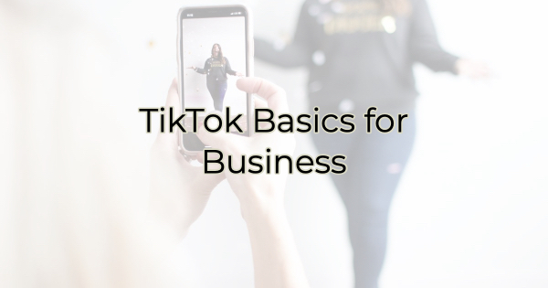

Are you on TikTok? Maybe you’re just figuring out video and livestreaming and you have written off TikTok as a site for kids.

While you aren’t wrong about that (32.5% of users are between 10 and 19, while 41 percent of TikTok users are between 16 and 24 years old), the TikTok adult audience has grown at a rate of about 5.5 times in just 18 months.

The app now boasts 1 billion active users. TikTok videos are becoming a way to pass time for many people and the average user spends about 52 minutes per day on the app. It also has huge reach. 167 million TikTok videos are watched in a minute on average.

So, if you’re looking to reach an under 35 audience in your business, TikTok might be the avenue for you. Here’s what you need to know as a beginning user:

TikTok Basics for Business
If you’re new to TikTok or are considering it for your business, it’s a little different than other social media platforms.

Premise
TikTok is a video platform. Some people lip sync, act, create short video blogs, or showcase their products. Humor is a popular driver for likes on this platform.

Before creating anything, think about visuals and short, punchy ideas. This is not the place for a long diatribe. The audience is constantly swiping and liking. Comments will tend to be shorter and emoticon driven.

There are lots of editing options in app, but some people still prefer to use other programs (like Canva) to create videos and then upload them to TikTok. Going viral on this platform seems a little easier than Facebook or YouTube.

Business Accounts
Like most social media platforms, you can—and should—create a business account, instead of a personal one. The main reason for this is that it will keep you out of trouble. A creator account is a copyright infringement waiting to happen because the app allows users to attach music (and not the safe royalty-free kind either) to their videos. While Kenny Chesney may not sue a parent for adding his latest song to the background of a video of their kid’s first step, you can be certain he’s not going to want people associating his music with their product (not that he has anything against your product, of course. It’s just that he—and any other music creator—is going to want to be compensated for his music. While I don’t speak for Kenny, proving me wrong about how he feels regarding your product by using his music without permission could be quite costly for your business). It's just too easy to get yourself in copyright troubles with a creator or personal account.

Business accounts have music available as well but none of it will get you in trouble with rights holders. The music available on the business side is royalty-free. A business account also has analytics that personal accounts don’t.

Links
Like Instagram, website links are a bit of a challenge at first. TikTok doesn’t let you have a link in your bio until you reach 1,000 followers. It used to allow businesses to add a link before the 1,000-follower mark but that changed in January. These days, you must meet the follower threshold for links and the ability to go live.

Hashtags
TikTok is another hashtag driven site. There are very specific hashtags used here. For instance, for writers there’s #BookTok, #writertok, and #authorsoftiktok. There are hashtags for business like #biztock and #smallbiztok. Take some time to research these. They are very specific but will help you find your ideal audience.

Filters and Film-Ready Face
If you’re like me, you may have some hesitancy being in front of the camera. Heck, most of us barely make it out of pajamas these days, let alone put on makeup or look presentable on camera. To this challenge, there are several solutions:

- You don’t have to show your face. People do a lot of things with babies, pets, products, etc and subtitles.
- Use a filter. You can alter the way you look using filters. I understand there’s even a perfect skin and makeup filter (I’m still looking for that one.).
- Record your videos on “shower day.” You can make yourself camera ready and record several at once.

Sponsored Toks
TikTok, like other apps and social media platforms, allows for sponsored videos. They appear in a user’s stream marked as sponsored but they blend in quite well. Most businesses that pursue this option also use either influencers to record the video or create their own. This is not the place for a formal commercial. You want to think about fun entertainment, not a salesy pitch.

Video
The best way to figure out TikTok is to go in and start playing around. (Here are the app’s directions for video creation.) If you’re older than 40, you may feel like you’re crashing a kid’s party at Chuck E Cheese at first. But stick with it. Scroll through until you find a video you like. When you do, you can use the same effects they use by clicking on the links in the video.

On TikTok, imitation is the sincerest compliment. No one thinks anything of copying someone else’s Tok (unless that someone else is your competitor. You might want to avoid that.)

You can create, like, and share content on this platform. If you entertain and are true to yourself and your business, you’ll quickly amass followers and likes (they are counted separately as are your video views). Keep in mind the social rules you use on other platforms should be used here too. When people comment on your Tok, respond back. Don’t simply publish. Like other people’s work and comment on their posts as well.

If you want to learn more about using TikTok for your business, check out TikTok’s business page.

Christina R. Metcalf (formerly Green) is a marketer who enjoys using the power of story and refuses to believe meaningful copy can be written by bots. She helps chamber and small business professionals find the right words when they don’t have the time or interest to do so.
Christina hates exclamation points and loves road trips. Say hi on Twitter or reach out on Facebook.

