What Customers Want Post-Pandemic

The results of a recent survey commissioned by GoDaddy and conducted by OnePoll of 2,000 Americans and what they want from small business going forward, shouldn’t surprise business owners. But if you’ve been thinking that some of the things you did for safety purposes can be phased out once we start beating the numbers on this virus, you may be in for a rude awakening.

Just like our kids on summer vacation, our customers have gotten used to a certain way of life and they expect businesses to help them maintain it.

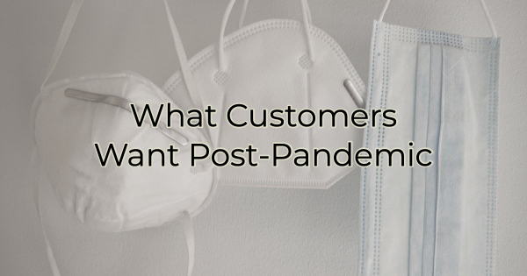

What Customers Want
First, customers appreciated how most small businesses changed their offerings and ways of doing business with the pandemic.

Here are the eight things that are most important to buyers:

- Contactless payment options
- Curbside pickup
- Online stores
- Self-checkout
- Virtual/digital loyalty cards
- Mobile apps
- Ordering ahead online
- QR code menus

Not surprisingly, 68% of respondents said they would shop from small local stores more often if they could purchase items online.

What Do the Results Mean for Small Business?
There’s very little interpretation needed here. Consumers are in love with convenience methods.

You may have originally implemented these conveniences for safety protocol, but it turns out many of us like having food and items brought to our cars. We love tapping credit cards at payment terminals and we like ordering things in our PJs and having them delivered.

Wise businesses have likely already invested in these things, but they may have done it with the idea that these protocols would be temporary.

Knowing this is what many customers prefer may have small businesses everywhere rethinking a few things.

These preferences may change:

- The size of buildings businesses operate in – more carryout or online shopping means less need for room for eating or browsing. Some businesses may give up brick and mortar all together. Some restaurants may close dining altogether and offer a Sonic-like, carhop model of service.
- The number of staff they employ and how they are allocated – more desire in online shopping means fewer jobs in face-to-face sales in some industries and more options in online tech.
- A good majority of employees working online will be able to relocate to areas where their type of work may have been (previously) hard to find, like tech employees moving to the beach.
- Work hours may become more flexible, outside of the 9-5 or even traditional retail hours. Focus will be on productivity, not clock punching; task oriented, not time oriented.
- Bandwidth and internet, areas may start looking at offering increased free public internet (most of Australia’s major cities, for instance, have already adopted and made major investments in this).

Some people still enjoy getting out of the house. Others love the instant availability of purchasing things in-store.

Finally, it’s important to note that all this desire for easy ways to shop from home is predicated on several factors including the ability for businesses to find employees, navigate the supply chain issues (so availability can still be used as a unique value proposition over waiting for an online delivery), and other side effects of the pandemic.
Will you continue these customer favorites once we come out on the other side of this pandemic or will you go back to how you used to do things years ago?

Christina R. Metcalf (formerly Green) is a marketer who enjoys using the power of story and refuses to believe meaningful copy can be written by bots. She helps chamber and small business professionals find the right words when they don’t have the time or interest to do so.
Christina hates exclamation points and loves road trips. Say hi on Twitter or reach out on Facebook.

