10 Ways Nonprofits Can Work with the Chamber to Finish the Year Strong

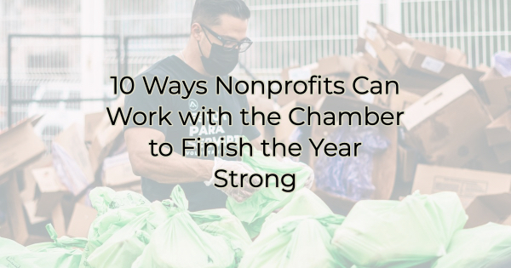

December is a critical time for nonprofits, as it marks the final stretch of the year to achieve fundraising and community impact goals. But what you might not realize is how a chamber of commerce can help your holiday giving campaigns. The chamber can be a valuable resource to support your mission going into December and beyond.

1. Year-End Giving Campaigns with a Twist
While a direct ask is nice, you’re one of many requests that a business is receiving this time of year. Instead, create unique year-end giving campaigns that stand out. Emphasize personal stories and impact achieved throughout the year. If you’re a member of your local chamber, they may be able to assist with promoting these campaigns through its network and marketing channels.

2. Collaborative Fundraisers
Collaborate with local businesses for joint fundraisers. Nonprofits can team up with chamber member businesses to host events or initiatives that benefit both parties. It's a win-win scenario for the nonprofits and the local economy.

3. Chamber Member Donor Matching
Work with the chamber to establish a donor matching program for nonprofits. This program would encourage chamber members to match donations made to nonprofits during the holiday season, amplifying the impact of charitable giving.

Another idea is to see if they have a shop local campaign. If so, and you are a local charitable organization, see if they will also add a “Give Local” component to their campaign.

4. Volunteer Appreciation Events
Host a volunteer appreciation event in collaboration with the chamber. Recognize the dedication of your volunteers and express your gratitude. The chamber can assist in helping you promote volunteer opportunities. They may even want to get their board involved. But you won’t know if you don’t ask.

5. Community Impact Showcases
Work with the chamber to organize a community impact showcase event where nonprofits can display their achievements and projects from the year. This can help create awareness and support for their causes. If the chamber has a Leadership Program, they may have a nonprofit session day that you could be a part of. The chamber may also assist in promotion of your events.

6. Holiday-Themed Workshops
Offer workshops or webinars focused on end-of-year fundraising, grant writing, or volunteer management, with support from the chamber's experts and resources.

7. Networking Mixers
If you’re a chamber member, consider the benefit behind attending networking mixers or other chamber events where you can connect with local businesses and potential donors. The chamber can facilitate introductions and provide a platform for these connections to flourish. If you’re not a member, you can likely attend an event as a guest and try it out.

8. Year-End Gratitude Campaigns
Express your gratitude to donors, volunteers, and the community. Create heartfelt thank-you videos, letters, or events to show appreciation and foster strong relationships.

9. Leverage Chamber Resources
Talk to your chamber to better understand what resources are available to members such as marketing support, access to a network of local businesses, and promotional opportunities through chamber channels. Decide how you might work together for the better of the community as you take advantage of these benefits.

10. Plan for the Year Ahead
Use December as a time to strategize and set goals for the upcoming year. The chamber can assist you in developing sustainable plans for growth and community impact. Find out what their strategic plan is. Your work may align with their initiatives as well.

December is not just the end of the year; it's also the perfect opportunity for nonprofits to create lasting impacts and strengthen their relationships with the community. By implementing these ideas and utilizing the support of your chamber, you can finish the year strong and pave the way for a successful year ahead.

Let’s make a meaningful difference in our community.

Christina Metcalf is a writer/ghostwriter who believes in the power of story. She works with small businesses, chambers of commerce, and business professionals who want to make an impression and grow a loyal customer/member base. She loves road trips, hates exclamation points, and believes the world would be a better place if we all had our own theme song that played when we entered the room. What would yours be?
_______________________________________
Twitter: @christinagsmith
Facebook: @tellyourstorygetemtalking
LinkedIn: @christinagsmith

