Chamber Pros, are you looking to increase membership in 2023? Want persuasive content that will help people understand the value in the chamber? Are you planning to launch an email nurturing campaign but just can’t seem to find the time to write it?

We have you covered! Introducing the New Year, New Members content series.

Over the next month, we will bring you content that you can tailor for your chamber and future members. Each of these posts can be used on your blog (and will be blog/article length). You can also pull pieces from the posts to create your own email nurture campaign.

But who has time for that, right? So…

The fourth and final post in the content series, will be an e-mail nurturing campaign formula and copy to interest future members.

The series contains:

- Week One: 3 Reasons to Join the Chamber in a Time of Economic Uncertainty
- Week Two: What’s in Chamber Membership for You? Hint: it’s more than just a ribbon cutting
- Week Three: What Does It Mean to Be a Chamber Member?
- Week Four: Future member e-mail nurturing campaign (Chamber Pros, we’ll give you the copy. All you have to do is set it up to send.)

We hope you are as excited as we are and that this provides a great start to your chamber marketing.

3 Reasons to Join the Chamber in a Time of Economic Uncertainty
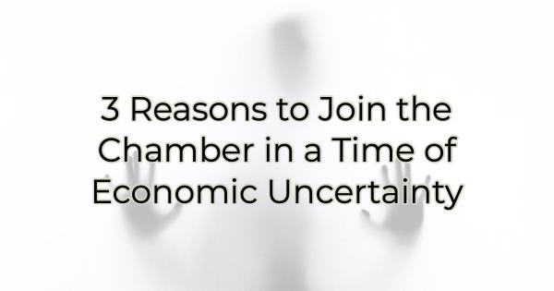

Times of economic uncertainty don’t cause anyone to look for new ways to spend money. But there are some investments in your business that even when you’re worried about cash flow, are worth the return. Without those necessities—be they software or services—you couldn’t operate. Chamber membership is one of those necessary business investments and here’s why:

Uncertain Times Mean Unprecedented Business Challenges
According to a survey released in early January by the National Association for Business Economics, more than half of respondents believe the U.S. is headed toward a recession in the next 12 months. An additional 11% of those polled think the economy is already in a recession. (A recession is commonly defined as two consecutive quarters of shrinking growth). However, the severity and depth of the possible recession are matters of debate among most economists and market experts.

Whether we face a recession or not, growth is slow. Costs are up. Shelves are not as full as they once were. Some industries are already claiming a recession has hit them.

In times of economic uncertainty, businesses have greater needs than usual. It helps to have a partner looking out for your best interests. The chamber is in a unique position to provide that assistance for a minimal investment.

The Hidden Job Market
One of the reasons economists are slow to call what we’re in currently “a recession” is because the job market on average remains strong. Employers are hiring. Sometimes their hiring needs are even outpacing available, skilled candidates.

Through chamber membership, you receive two types of job assistance—help in finding positions and candidates. If you’re looking for a job, you can network and locate available opportunities in the hidden job market (before they come available). Membership helps you get to know hiring managers and business owners, making a job search much easier and improving your chances of finding your dream job.

On the other hand, as a hiring entity, you will be in a solid position to get to know potential job candidates who aren’t actively looking for work. This is often one of the easiest ways to find top performers. Plus, connecting with possible job candidates on a professional level outside of the office can assist you in getting to know them better than you would through a 30-minute interview. This helps to ensure a stronger hire and better fit for your organization.

Public Sector Assistance & Advocacy
Whether you have your eye on pro-business legislation or are worried about a zoning issue, like anything else, business often goes your way based on who you know. As a chamber member, your concern over business—your own or the entire business community—is amplified. When the chamber speaks to city, state, or federal leaders, they are speaking on behalf of all businesses. This gives your concerns more power among elected leaders.

The chamber may also be able to help by placing your request in context in the larger picture. The zoning problem you’re having isn’t just about your business property but all properties moving forward. The chamber is well-suited to propose “if, then” scenarios that can help you get the assistance you need quickly.

Economic Development
While economic development of the area may not seem like a pressing issue in your mind right now, it helps keep you in business, regardless of your industry. A strong local economy can help maintain prosperity even when the national economy is struggling like the minority-business owners did along Auburn Avenue in Atlanta in the 1930s. While the rest of the country was experiencing the dark crash of ’29 and subsequent depression, Auburn Avenue thrived because its interests were protected.

The chamber is dedicated to building community and ushering in smart economic growth so everyone can thrive. Chamber membership not only safeguards your business interests and helps you achieve your own goals but improves the business community, and thus the community, for all.

Christina Metcalf is a writer/ghostwriter who believes in the power of story. She works with small businesses, chambers of commerce, and business professionals who want to make an impression and grow a loyal customer/member base. She loves road trips, hates exclamation points, and believes the world would be a better place if we all had our own theme song that played when we entered the room. What would yours be?
_______________________________________
Twitter: @christinagsmith
Facebook: @tellyourstorygetemtalking
LinkedIn: @christinagsmith

