4 Things You Must Be Doing This Small Business Season

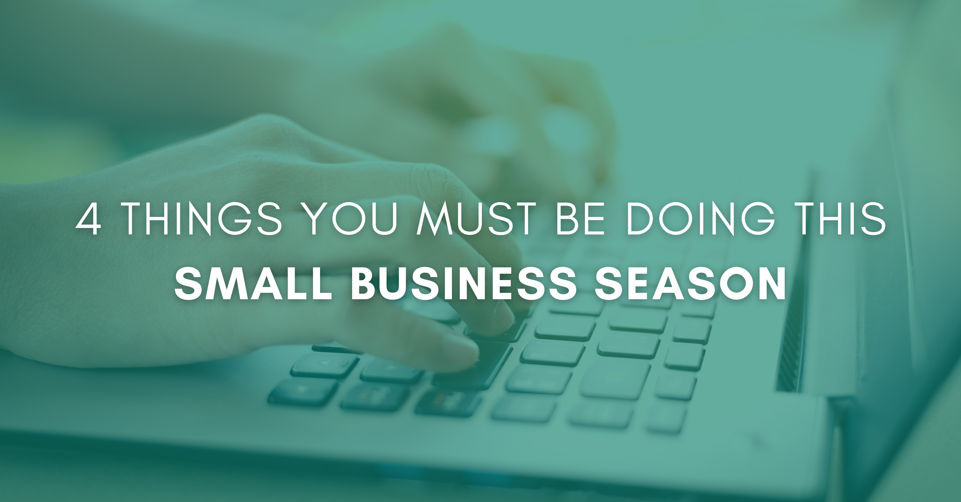

We’re down to the last two weeks before Christmas with some of the biggest shopping days of the season still ahead of us. Since every sale can help your future marketing, it’s essential that over the next few weeks you think not only of the money, but the data you can garner from each sale as well. But don’t stress. You still have time to implement these important activities for big results.

Things You Need to Do During Small Business Season
Don’t let the biggest sales season go by without gathering this data and implementing some of these activities to help with future marketing:

Build Your List
You have a lot of people interested in what you sell or the service you provide. When people buy from you ask them if they’d be willing to sign up for a VIP list that will give them special discounts or coupons. They get savings, you get a way to stay in contact with them.

Notice the Also Boughts
Ideally, you have a point-of-sale system that could quantify the sales data you’re gathering to tell you what people who buy from you often buy together. But if you don’t have that in place, you can do it manually by paying attention to items or services that sell well together. Then get that information to your staff so that they may make satisfying suggestions to customers.

Email Last-Minute Offers or Deals
If you already have an email list of past customers, send out a discount or last-minute offer email to them. People who have purchased from you before are more likely to buy again.

Buy one, get one offers are particularly beneficial in driving sales because they allow people to buy for two people inexpensively, get more for less, or keep a special something for themselves.

Who doesn’t love that?

Excel in Social Media
Now is the time to blow up your engagement on social media. Search on social for hashtags of things you sell or specialize in. If you find someone looking for those things, you can start a conversation about it.

If you’re sold out of the item they want, suggest where they might be able to find it. They’ll appreciate the help. Post funny videos. Interview people about their holiday shopping (don’t forget that media release!). Highlight some of your more unique items/services or your best sellers.

Analyze what gets results and do more of it. Tag your local chamber in these posts and they might share your content as well.

This is a critical time to get sales, but revenue isn’t the only benefit to your business. Every sale provides critical information about your ideal client. The more information you have for analysis, the closer you are to the kind of personalized marketing that gets results.

Christina R. Metcalf (formerly Green) is a marketer who enjoys using the power of story and refuses to believe meaningful copy can be written by bots. She helps chamber and small business professionals find the right words when they don’t have the time or interest to do so.
Christina hates exclamation points and loves road trips. Say hi on Twitter or reach out on Facebook.

