5 Components of a Standout Job Description in 2022

The past two years have brought about a lot of change in business. But many companies haven’t reevaluated their job descriptions. Every time they have a position to fill, they search a hard drive (or folder) and post it. This won’t keep you competitive in the employment arena.

While there are basic elements you need in a job description like explaining what the job entails and the expectations, it’s the extras that will inspire people in this job hunter’s market to apply.

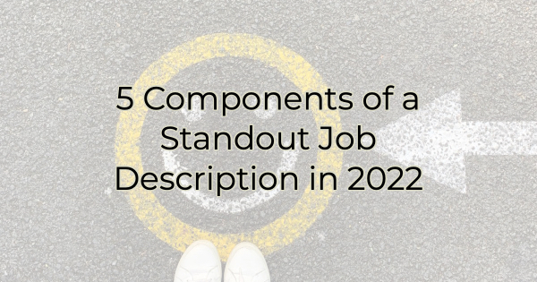

In addition to the basics, a great job description for 2022 includes:

- Consistent corporate/business tone and brand
- Logical keywords
- Location
- Hours
- New (soft) skills

Components of an Enticing Job Description
When creating a job description, it’s not a race. It should be a combination of good HR practices, marketing/corporate branding, and sales. After all, this is an advertisement for your business as much as it is an ad for employment. In 2022, you should ensure it:

Matches Your Corporate/business Tone and Brand
It’s all the rage to create fun and engaging titles with witty words, but if that is not a reflection of your true business culture, new employees will be disillusioned. Make sure your job description sounds like you. After all, you wouldn’t send a formal foil-embossed invitation to a pool party. Don’t use a job description that sounds like something you aren’t.

Includes Logical Keywords
Very few of your applicants are scrolling through an open jobs section like they might’ve twenty years ago. Instead, they are typing or using voice search on keywords to locate jobs that fit their qualifications. They’re also signing up for notifications on these keywords. While fun job titles are, well, fun, they leave something to be desired when people are searching for openings in their field. Save the fun titles for business cards or your website and use titles with meaningful keywords to help potential employees find you.

Specifies Location
Location, location, location. And that means being specific about remote work as well. There are some industries where candidates will assume the ability to work from home unless you say otherwise, or they may expect it is negotiable. Be specific about where they’ll work and whether that is consistent or flexible.

Includes Hours
Be specific about the hours your employee will work. Are weekends required? Can you guarantee a certain number of hours? Again, like location, some industries offer flex hours with floating starting times (for instance, between 7-9 AM). If the position allows someone to work when children are in school, that should be mentioned too as it is a nice selling point/perk.

Incorporates New Skills
If your job description is over three years old, you want to reevaluate it. There are skills required of today’s employees that weren’t expected even a short time ago and you want to make sure they are included. For instance, if the team works virtually, you may add something about working well in a virtual office environment. If your retail business now also requires e-commerce skills or social media, you’ll want to add those. If you have a diverse business culture you may want to add something about emotional intelligence and a diverse workplace. Look at how things have changed in your business and make sure the job duties and skills reflect those changes.

Finally, give some thought to also including information about salary. Sure, it’s likely based on experience, but you don’t want to waste anyone’s time wading through resumes or applications for people who would never consider your position for what it pays or are not at the right level of their career to apply. Including sensitive information like salary/pay may feel uncomfortable at first but it saves everyone time and effort. In today’s market, that’s greatly appreciated.

In conclusion, before uploading your job description to a job search website, consider how it reflects on the culture of your business and review the description with a 2022 vision. A lot has changed over the past two years and if you’re using the same old job description from five years ago, you may not get the type of applicants you want, or need, to be successful.

Christina R. Metcalf (formerly Green) is a marketer who enjoys using the power of story and refuses to believe meaningful copy can be written by bots. She helps chamber and small business professionals find the right words when they don’t have the time or interest to do so.
Christina hates exclamation points and loves road trips. Say hi on Twitter or reach out on Facebook.

