5 Ways to Level Up Your Small Business Marketing (and yes, it’s time)

If you’re interested in ways to reach more people, and you’re ready to start maximizing technology, it’s time to look at these business solutions:

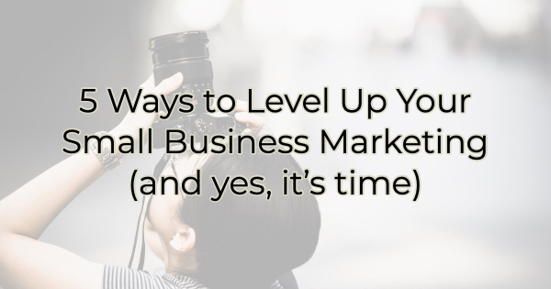

List Building
You need an email list. It’s the best way to stay in touch with your customers, nurture them into a sale, and then remind them to come back. The other benefit to an email list is that it’s yours. You won’t lose access to it if you’re in Facebook jail or one of your social media platforms goes the way of MySpace (for those of you who are old enough to understand that reference).

Here are a few ways to build an email list.

Marketing Automation
Now that you have a list, it’s time to start talking about marketing automation. There are tons of marketing or e-mail automation tools out there from enterprise software to free aps. There’s an initial time investment to set the campaign up, but once the initial set up is done, you’ll have a wealth of options to help you grow your business and stay connected with your customers.

Learn more about marketing automation and how to get started.

Copy Tricks and Content Marketing
Copywriting is the art of persuasion in the briefest of characters. These days, most audiences are more won over by eye-catching images than long prose. But you still need compelling copy for website visitors of the human and search engine kind. If you don’t have a marketing person or you’re not freelancing it out to a professional, take a weekend to brief yourself on the basics of copywriting. You won’t be a copywriting pro in just a weekend but your efforts will show.

Here’s one idea that’s incredibly important to making sales. If you are giving your customers a choice between three levels of service, mark one as the “best value” or “most popular.” There are many customers who want to be told what to do, albeit subtly. Marking an option with this type of designation persuades them into choosing what others have.

Also, make sure all your pages have a call to action that fits the level of the relationship/page content. If the page is based around the visitor getting to know you, for instance, don’t immediately ask for the sale. It doesn’t fit what they’re trying to do. A pop-up for content on how to make an educated purchase decision for what you sell is a better fit.

Chatbots
People want answers on their schedule. A chatbot can help you stay in touch with your audience and potential customers when they have a question or concern, even when your business isn’t open.

Here are a few ways you could be using them.

Ask
I wanted to throw in an idea for the non-techies as well. Some of the other components mentioned here can be a bit overwhelming at first. This one is as basic as speech. Start a conversation with your customers, vendors, or a similar audience to your own who aren’t customers yet. Become more social. Listen to what people are talking about, what they need, what they like. If you have a brick-and-mortar store, talk to people when they come in. Run your branding by them. Go to a festival and host a pop-up booth. Sure, you may have some sales, but it’s also a way to get in front of a different audience and talk to people. Then use all that information to change how you communicate with others and market to them.

There are a lot of ways to increase sales these days. Much of the marketing technology has become less expensive and does more. But all these solutions do take time. Just as people say it takes money to make money; it also takes time. Thankfully, it doesn’t have to be your time. If someone can do it more efficiently than you can, let them and concentrate your efforts on the things that only you can do for your small business.

Christina Metcalf is a writer/ghostwriter who believes in the power of story. She works with small businesses, chambers of commerce, and business professionals who want to make an impression and grow a loyal customer/member base. She loves road trips, hates exclamation points, and believes the world would be a better place if we all had our own theme song that played when we entered the room. What would yours be?
_______________________________________
Twitter: @christinagsmith
Facebook: @tellyourstorygetemtalking
LinkedIn: @christinagsmith

