Google Map Help

If click on the link from monticellochamber.org, while on a computer:
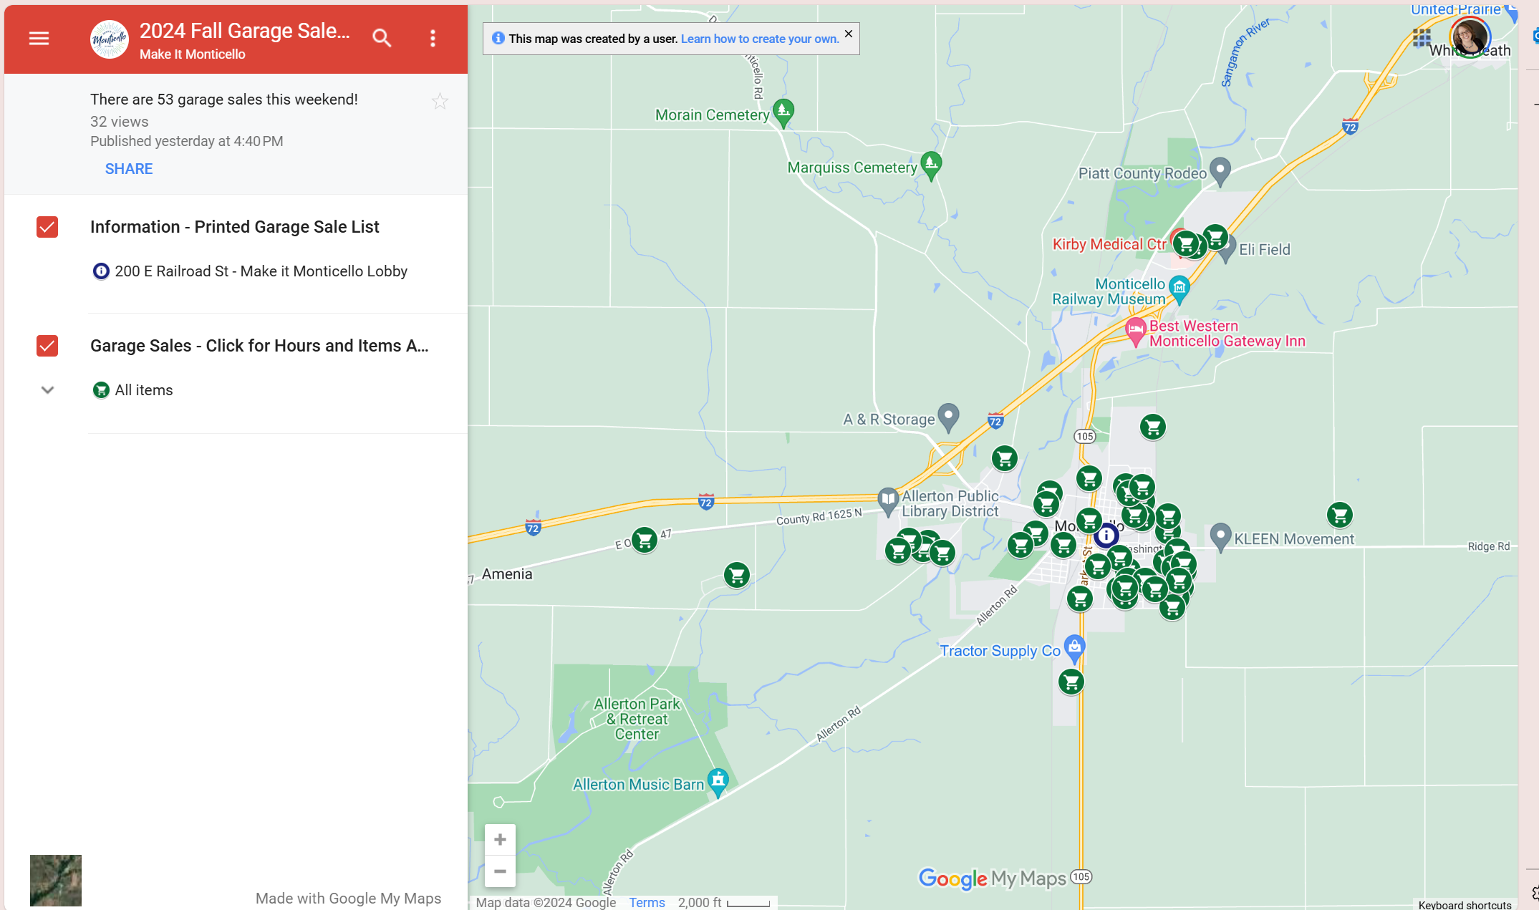
Click on the down arrow beside All Items (under Garage Sales) and a list of each sale will show up. If you click on either the shopping cart on the map or the address in the list additional information on hours and items for sale will show up.

If you click on the link from monticellochamber.org, while on your phone, and it opens in the google maps app:
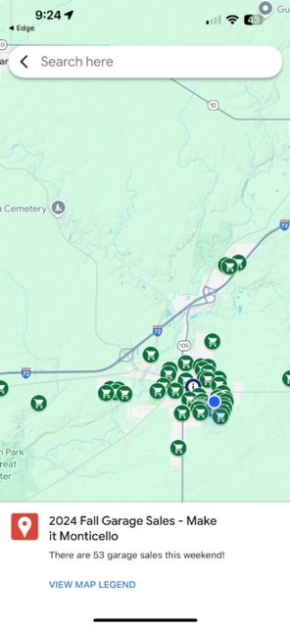
Pinch to Zoom. Click on each icon to get specific details for each location. Click on the Directions button for driving instructions from your location

If you are using from the QR code found on the printed map or click on the link on monticellochamber.org, from your phone, and it opens in your browser:
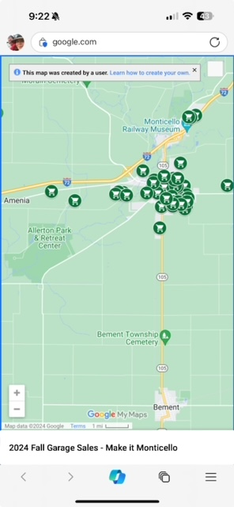
Pinch to Zoom Click on each shopping cart icon to see the address at the bottom of the screen. Click on the address for more details. Click on the sign icon on the right side of the red address band for driving directions.

If google just isn’t right for you…swing by the Wabash Depot (our Tourism Lobby) and grab a printed map and list. 200 E Railroad St, Monticello IL 61856

