Harnessing TikTok’s Engagement Magic

Why building a castle on the sand is not always a bad thing

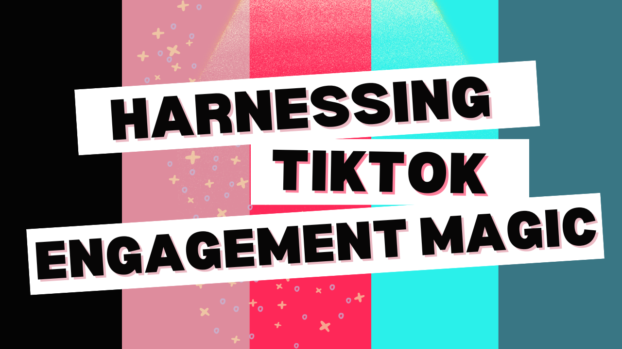

TikTok has been likened to the Yukon—a vast wild place with enormous potential for engagement gold. But also, a potential dark side. That’s part of its allure and if you’re target market is under 40, you’re likely on it (or considering it).

TikTok has revolutionized the way brands connect with audiences. Its addictive short-form video format, fueled by trends, challenges, and a powerful algorithm, has become a goldmine for businesses and creators alike. In fact, TikTok boasts higher engagement rates than Instagram and YouTube, and many creators report significantly higher earnings on the platform.

Even if you’re not monetized on it, you have most likely seen much larger views of your content there than the other video platforms. That’s due, in part, to its users’ voracious appetites for video. Your content *will be* seen—although it may not be watched (through its entirety, or anything close to it).

But savvy business owners know that relying solely on any single platform, even one as potent as TikTok, is a risky strategy. What happens if the algorithm shifts, your content gets shadowbanned, or the platform itself faces regulatory challenges (a very real concern for TikTok)?

That's why diversifying your marketing efforts is crucial.

Instead of abandoning TikTok (views, clicks, and higher monetization rates make it worth staying), leverage its strengths to fuel your presence across multiple platforms.

Here's how:

## Capture the TikTok Magic Across Platforms

TikTok's success isn't just about the platform; it's about the style of content. Sure, there are a lot of theatrics and trends that last a hot second, but “real” video is making a strong comeback. And the TikTok audience loves it so much that this trend is spreading into other channels as well.

Think:

* **Authenticity**. Ditch the polished corporate vibe. Embrace raw, relatable content that showcases your brand's personality and company culture.
* **Storytelling**. Condense compelling narratives into bite-sized videos. Whether it's a customer testimonial, a behind-the-scenes glimpse, or a product demo, keep it concise and engaging.
* **Speed.** TikTok is an exercise in shortening, much like the quote, “Just the facts.” But in TikTok’s case, it could be reworded to “Just the Fun.” Condense everything you want to say into the shortest space you can do it in. Once you master this technique, you’ll appreciate how it can apply to other facets of your business. When you start looking at data, you’ll see how quickly people move on from your video on this platform. But don’t feel dejected. A lot of them will drop off and still give you a heart. The average user of this site is a hummingbird and they’re always moving onto the next flower.
* **User-Generated Content (UGC).** Encourage your audience to create content featuring your brand. Run contests, challenges, or simply re-share engaging posts from your followers.

## Have TikTok Will Travel

Now that you understand the magic of TikTok and why so many people love it, you can apply what you’ve learned about creating content on that channel and use it on others such as:

* **Instagram Reels**. It’s a natural fit for TikTok-style content. Experiment with similar editing techniques, trending audio, and interactive features.
* **YouTube Shorts**. Reach a wider audience with your short-form videos and potentially drive traffic to your longer YouTube content.
* **LinkedIn (for B2B).** Yes, even LinkedIn! While the tone may be more professional, short videos showcasing company culture, employee spotlights, or industry insights can be surprisingly effective.

## TikTok as Your Creative Lab

Use TikTok as a testing ground for new ideas and content formats. A viral TikTok trend can be repurposed and adapted for other platforms. Trends also seem to be birthed on TikTok, fade quickly, and then migrate to other platforms, making TikTok the ideal marketing innovation lab.

Keep an eye out for things like:

* **Hashtag Challenges:** A successful challenge on TikTok can be translated into an Instagram campaign with user-generated content or even a blog post featuring the best submissions.
* **Trending Audio:** If a particular sound is performing well on TikTok, consider incorporating it into your Reels or Shorts.
* **Product Demos:** A quick and catchy product demo that goes viral on TikTok can be re-edited for a YouTube Shorts tutorial or an Instagram story series. (Don’t forget the TikTok shop if you sell products.)

## The Power of Cross-Promotion

Skilled marketers don't treat their platforms as isolated silos. They use them to drive traffic and engagement across their entire online presence. Each channel/platform has its own quirks and personality. Learn them and you’ll see what can be tweaked for successful cross-promotion.

You can tie your channels together by promoting your other channels on TikTok. Include links to your website and other social media platforms in your bio and video descriptions. You can also tease upcoming content. Use TikTok to generate excitement for upcoming YouTube videos, blog posts, or product launches. Additionally, you can run contests that encourage multi-platform engagement by asking followers to like your Facebook page and subscribe to your email list for a chance to win.

## Diversification is Key

While TikTok is a powerful marketing tool, remember that the digital landscape is constantly evolving. By diversifying your strategy and adapting TikTok's winning formula to other platforms, you can build a more resilient and sustainable online presence.

Ultimately, regardless of the platforms you use, you want to build your email marketing list. Funnel your followers back to your site or landing page with a giveaway in exchange for their name and email. That way whether TikTok goes black, or Facebook loses its audience overnight, you can reach them no matter where they are.

[*Christina Metcalf*](http://www.christinametcalf.com/) *is a writer and women’s speaker who believes in the power of story. She works with small businesses, chambers of commerce, and business professionals who want to make an impression and grow a loyal customer/member base. She is the author of* [*The Glinda Principle*](https://www.amazon.com/dp/B0DHY261SG?ref=cm_sw_r_cp_ud_dp_CKZDC8XCEB5G2JXW92DJ&ref_=cm_sw_r_cp_ud_dp_CKZDC8XCEB5G2JXW92DJ&social_share=cm_sw_r_cp_ud_dp_CKZDC8XCEB5G2JXW92DJ&skipTwisterOG=1)*, rediscovering the magic within.*

*_______________________________________*

*Medium: @christinametcalf*

*Facebook: @tellyourstorygetemtalking*

*Instagram: @christinametcalfauthor*

*LinkedIn: @christinagsmith*