Why Workforce Development Is a Big Deal for Small Business

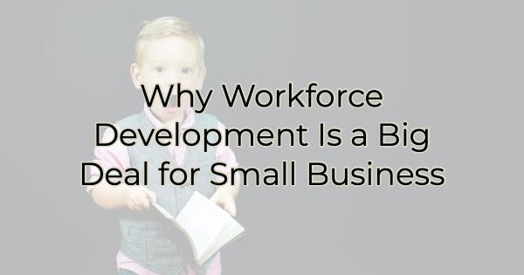

Many small and medium-sized business owners think that workforce development isn’t in their “lane.” They leave it to the big guys to work with the chamber and community leaders to ensure the large businesses have the skilled employees they need for the future. But unless you are a business of one and plan on remaining that way, workforce development should be a concern of all sizes of businesses. Here’s why you should want to get involved:

Why Small Companies Should Get Involved in Workforce Development

While workforce development may seem like a daunting task for small companies, there are several compelling reasons why they should actively engage in these initiatives:

- Access to a Skilled Workforce: By participating in workforce development activities with the chamber and beyond, small businesses can play a pivotal role in shaping the skills and competencies of the future workforce. This provides them with a pool of well-prepared candidates who can contribute to their growth and success. A single small business isn’t the main employer of the area but collectively, there’s a good chance they are. Workforce development initiatives should consider and incorporate the needs of all employers when possible. The chamber can’t do that if you don’t get involved.
- Enhanced Competitiveness: A highly skilled workforce gives small companies a competitive edge in the marketplace. By investing in employee development, businesses can improve productivity, innovate more effectively, and adapt to industry changes with greater agility. While your company may not have the budget to fund employee development, a workforce development initiative might. Working with leaders in workforce development can help you contribute your voice to the initiative while also benefiting from their programs.
- Talent Retention and Attraction: Workforce development initiatives signal to existing and potential employees that the company and area value employee growth and development. This fosters a positive work environment, boosts employee morale, and increases retention rates. Moreover, small businesses that actively participate in these initiatives become more attractive to job seekers who prioritize professional growth and development. And may help get the small company’s name out there in the job market.
- Building Stronger Networks: Engaging in workforce development activities provides small companies with opportunities to build relationships with educational institutions, industry peers, and other stakeholders. These connections can lead to collaborations, partnerships, and access to valuable resources and knowledge.

While small businesses may have limited resources compared to larger corporations, they have a unique opportunity to make a significant impact on workforce development. By engaging with the chamber of commerce, local educational institutions, industry associations, and larger companies in the area, a small business owner can provide valuable insights into what’s needed in the years ahead. Workforce development is not only crucial for individual companies but also for the overall economic growth and sustainability of the community.

Many small business owners think that as an employer of only a handful of people, their insights aren’t critical to the community’s plans. However, small business often comprises the largest employment segment in the area. Hearing from businesses under 200 employees is just as important as hearing from the largest employer. If small business owners don’t step forward to share their needs, the only ones who will be heard are big businesses and unless you think their employment needs and yours are the same, it’s time to speak up.

Contact the chamber today.

Christina Metcalf is a writer/ghostwriter who believes in the power of story. She works with small businesses, chambers of commerce, and business professionals who want to make an impression and grow a loyal customer/member base. She loves road trips, hates exclamation points, and believes the world would be a better place if we all had our own theme song that played when we entered the room. What would yours be?
_______________________________________
Twitter: @christinagsmith
Facebook: @tellyourstorygetemtalking
LinkedIn: @christinagsmith

